|  |  |  |  |
| --- | --- | --- | --- |
| Bioinformatics | **Bank Management System**  Members Of Team : 1 - Amr ahmed qasem 2 - abdelwahab alaa  3 - Mohamed Ezzat  4 - Mohamed abdelmaqsoud abdelmoneam   |  | | --- | | **Department : Bioinformatics**  **Responsible TA : Somaya El-Shawarby** | | **Supervised by : Dr. Abdelaziz Abdelhamid** | |

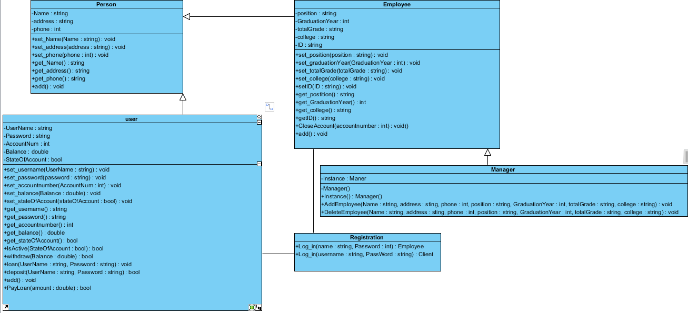1-Class Person:

Abstract class has three member variables ( name ,address and phone) with setter and getter function also it has a pure virtual function(add()).

2-Class Employee:

Class inherted from class Person .

Have 5 member variables ( Position , Graduation year , total grade , college , ID and account number) with setter and getter exept account number because this variable is static

It has a function Close Account ( int accountNumber)

It take Account number from the user and search it the check if state of account is open it will be close and return true and if state of account is closed it will be closed and return false.

3-Class Client :

Class inherted from class Person.

Have 4 member variable ( user name , password , balance and state of account ) with setter and getter

It has function IsActive() : return state of account.

Function withdraw (): take balance as a parameter and calculate the balance after withdraw process.

Function loan() : it take amount of money that the user need to loan it .

Function pay loan() : it take amount of money and calculate the difference between the amount of old loan and amount of money that entered.

Function deposit () : it take amount of money and add it to the amount of the balance .

Function Add() : to add new client.

4-Class Manger :

It has a static variable ( Instance ) and static function that create an object from this class .

Function delete_employee () : search for specific employee by ID and delete it .

Function Add(): take the data from the user and add employee.

5-Class Registration :

It’s associated with class Employee and Class Client.

Function Log_In() : return object from class Employee and take user name and id and log in .

Function Log_In() : return object from class Client and take user name and password and log in.

Manager

-Instance : Maner

-Manager()

+Instance () : Manager

Employee

-Position : string

-GraduationYear : int

-totalGrade : string

-college : string

- ID : string

+set_Position(Position : string) : void

+set_graduationyear(GraduationYear : int ) :void

+set_totalgrade(totalGrade : string) : void

+set_ID( ID :string) :void

+get_position():string

+get_graduationyear():int

+get_totalgrade():string

+get_college () : string

+get_ID() : string

+Close_account ( accountNumber : int ) : void

Client

-UserName : string

-Password : string

-Balance : double

-StateOfAccount : bool

+set_username(UserName : string) : void

+set_password(password : string) : void

+set_balance(Balance : double) : void

+set_stateOfAccount(stateOfAccount : bool) : void

+get_username() : string

+get_password() : string

+get_accountnumber() : int

+get_balance() : double

+get_stateOfAccount() : bool

+IsActive(StateOfAccount : bool) : bool

+withdraw(Balance : double) : void

+loan(UserName : string, Password : string) : void

+SignUp(Name : string, UserName : string, Password : string, address : string, Phone : string, Balance : double) : void

Person

-Name : strig

-Address : string

- Phone : int

+set_Name(Name : string ):void

+set_Address(Address : string ) : void

+set_Phone(Phone : int ) : void

+get_Name():string

+get_Address():string

+get_Phone():int

+add() : void